PROJECT REPORT


Project Title: Smart Traffic Simulation
Session: 2023-2027
(Reg No. 2023-UOK-045041)
(Reg No. 2023-UOK-04519)
Submitted To: Sir Bilal Ahmed
Subject: Computer Network
Submitted By: Arooj Yasin &
Quratulain Ashqaf
Date of Submission: Dec 3, 2025
DEPARTMENT OF DATA SCIENCE
FACULTY OF COMPUTING AND ENGINEERING
UNIVERSITY OF KOTLI AZAD JAMMUA AND KASHMIR

Abstract
This project presents a Smart Traffic Control system using IoT in Cisco Packet Tracer. IoT devices such as motion sensors, LEDs, and an LCD are connected through a network of servers, routers, and a home gateway. The system detects vehicle movement and automatically controls traffic lights, demonstrating an efficient and automated traffic management solution.
Introduction
The project idea is to manage traffic signals intelligently by integrating IoT sensors with a network infrastructure. Networking is crucial because it lets devices (sensors, actuators, servers) exchange data for automated decisions. In the real world, this can be applied to smart city traffic management, reducing congestion & improving safety.
Objectives
1. To create a smart traffic control system using IoT devices.
2. To connect all network devices by assigning proper IP addresses.
3. To automate traffic lights using a motion sensor.
4. To link IoT devices through the cloud and home gateway.
5. To test network communication using ping and simulation.

Tools & Software Used
Tool | Version | Purpose
Cisco Packet Tracer | 8.2.1 | Network Simulation & IOT Design
Windows OS | 10 | Host environment for Packet Tracer

Network Topology
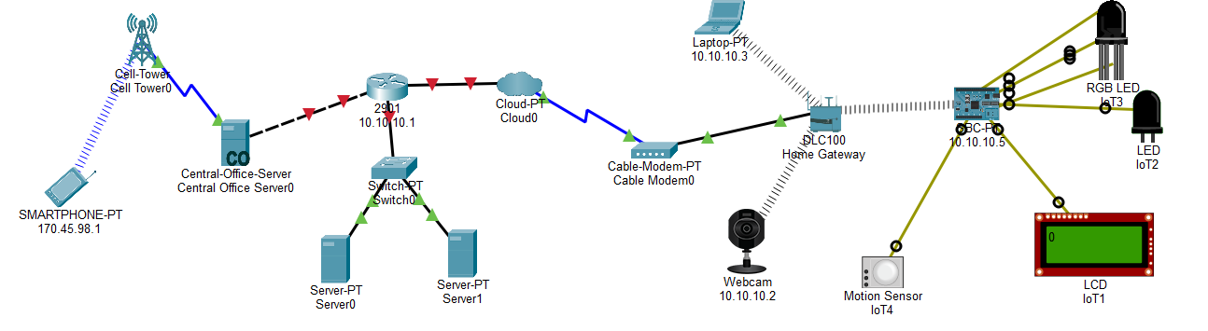
This network shows a Smart Traffic IoT System created in Cisco Packet Tracer.
A smartphone connects through a cell tower to the central office server. The server communicates through a router, cloud, cable modem, and home gateway. At the end, IoT devices such as a motion sensor, webcam, RGB LED, normal LED, and LCD are connected to an IoT controller. When the motion sensor detects a vehicle, the IoT controller automatically changes the LEDs and updates the LCD, enabling smart traffic control.
Device List
Device Name | Purpose
Smartphone-PT | control commands via cellular
Central-Office-Server | Manages IoT data & logic
Switch0 | Connects internal LAN devices
Cable Modem0 | Provides internet access to home gateway
Home Gateway (DLC100) | Routes traffic to IoT devices
Webcam | Streams video for traffic monitoring
Motion Sensor (IoT4) | Detects vehicles & triggers signals
LCD (IoT1) | Displays traffic status
RGB LED (IoT2) | Acts as traffic light indicator

Implementation Steps
1. Build the topology in Packet Tracer as shown.
2. Assign IPs to each device (e.g., Smartphone 170.45.98.1, Webcam 10.10.10.2).
3. Configure the server with IoT services & routing.
4. Connect sensors (Motion Sensor) to the gateway & program logic for traffic control.
5. Link IoT devices (LCD, LED) to the gateway for output.
Simulation & Testing
Run ping from Smartphone to Webcam & IoT devices to check connectivity.
⭐ Ping Commands (for Connectivity Testing)
1.Router
ping 10.10.10.1
2. Laptop → IoT Home Gateway
ping 10.10.10.5
3. Laptop → Motion Sensor
ping 10.10.10.4
4. Laptop → Webcam
ping 10.10.10.2
5. Laptop → LED (IoT device)
ping 10.10.10.6
6. Smartphone → Central Office Server
ping 170.45.98.1
7. Server → Router
ping 10.10.10.1
Observation: All pings should be successful, showing the network routes packets correctly.
Results & Discussion
Success: IoT devices communicate & control traffic signals as intended.
Challenges: Configuring IoT module logic & IP routing.
Solutions: Double‑check IP schemes & use Packet Tracer’s “simulation” mode to trace packets.
Conclusion
The project taught LAN/Wi‑Fi networking, IoT integration, and traffic‑management logic. Future improvements could include adding more sensors, AI‑based decision making, or integrating with a real cloud platform.
References
Here are some references for such a project
1. Cisco Packet Tracer – the software used to create this simulation; it’s widely used for networking labs and projects involving routers, switches, and IoT devices.
2.Online resources – Youtube , Google and AI tools
3.Classroom lectures Notes
GitHub Upload Project:
